**Fanka Shundovska**

**POSTMAN Homework 3**

* We will use **user section** on Swagger to perform the following CRUD (Create, Read, Update, Delete) Operations by the following order:
* POST/user- Create user and make test to verify the Status Code and the header to be Content-Type.
* GET/user/{username}- Get the user you created and make test to check the values of the json object as well as the status code (Total of 9 Tests).
* PUT/user/{username} - Update all the json properties with new values and make tests for status code.
* GET/user/{username}- Make tests for all json properties to ensure that it returns the updated values made with the PUT request (Total of 8 Tests).
* Delete/user/{username} - Make test for status code
* GET/user/{username}- Make test on the status code (404) to ensure the user is deleted.

**(Using variables is mandatory for this assignment)**

**Change at the Homework 3:** GET/user/{username}- Make tests for all json properties to ensure that it returns the updated values made with the PUT request (Total of 8 Tests, 7 Tests for updated properties and 1 Test for make sure that the id is not updated).

* POST/user

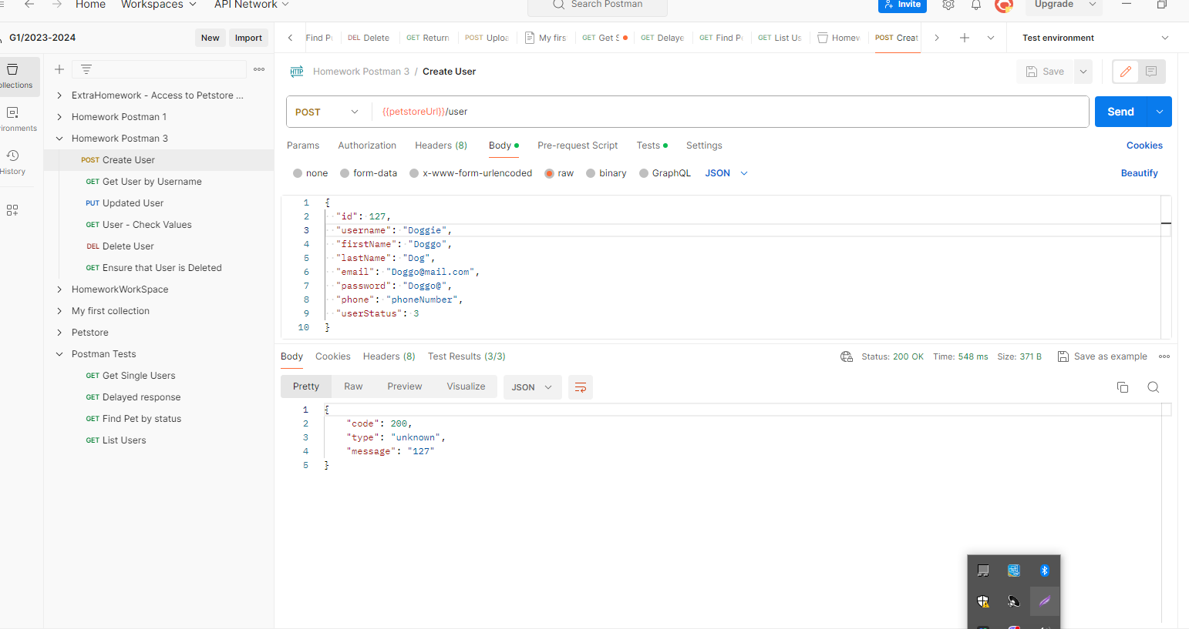

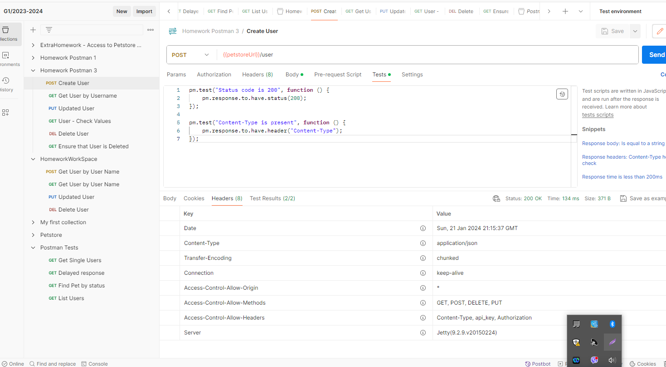

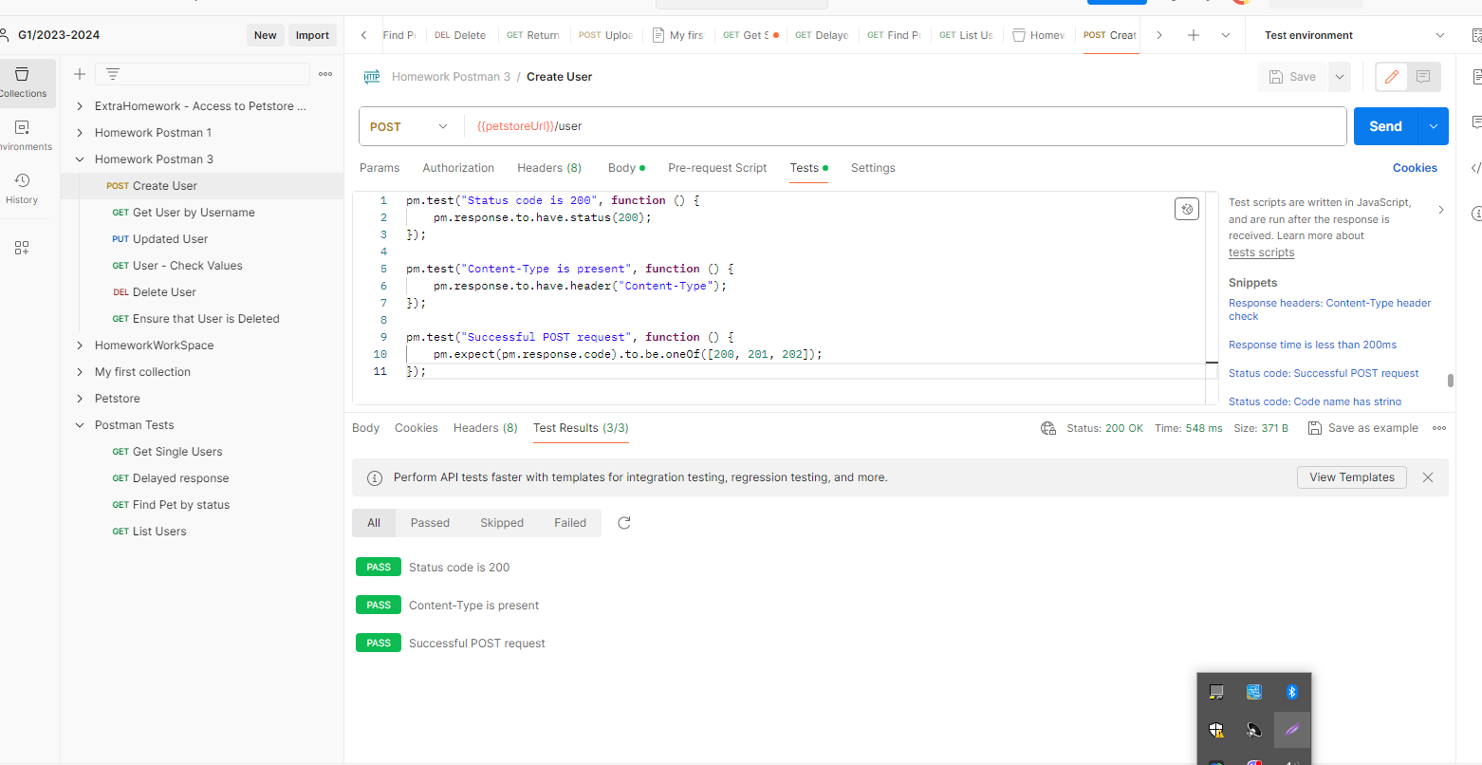

* GET/user/{username}

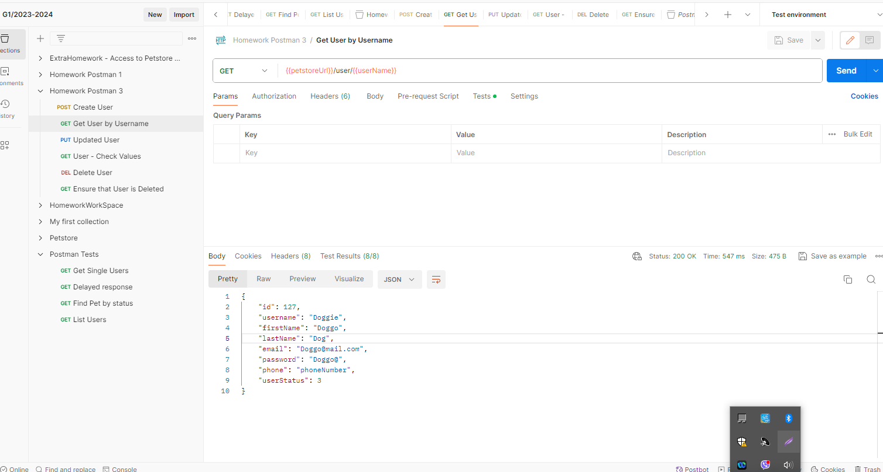

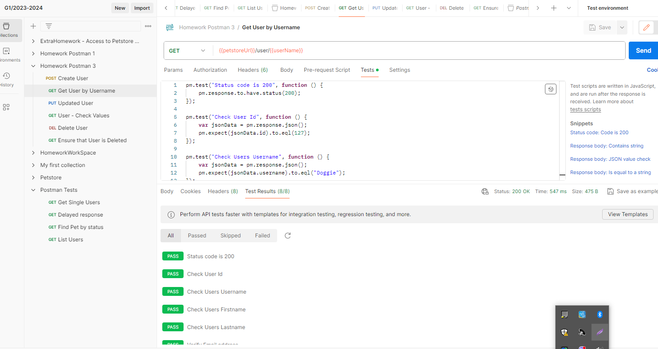

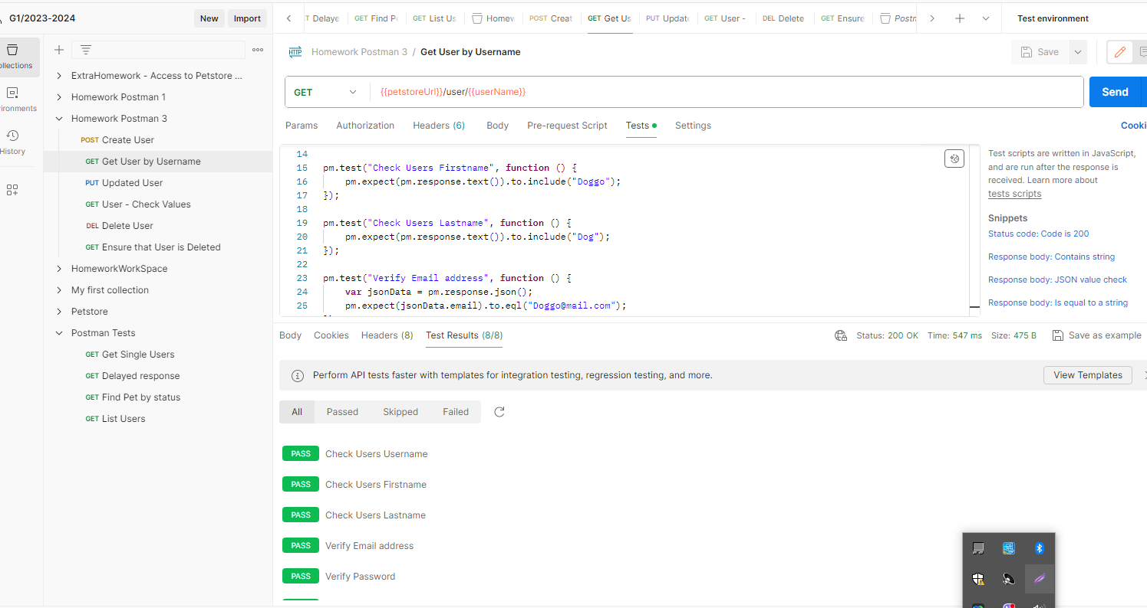

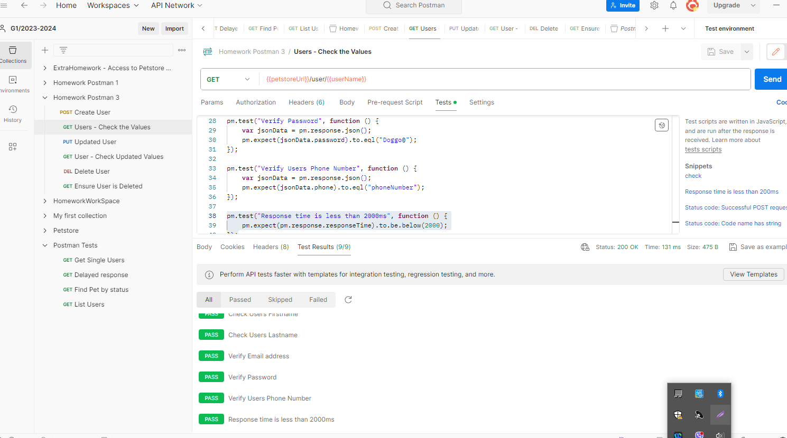

* PUT/user/{username}

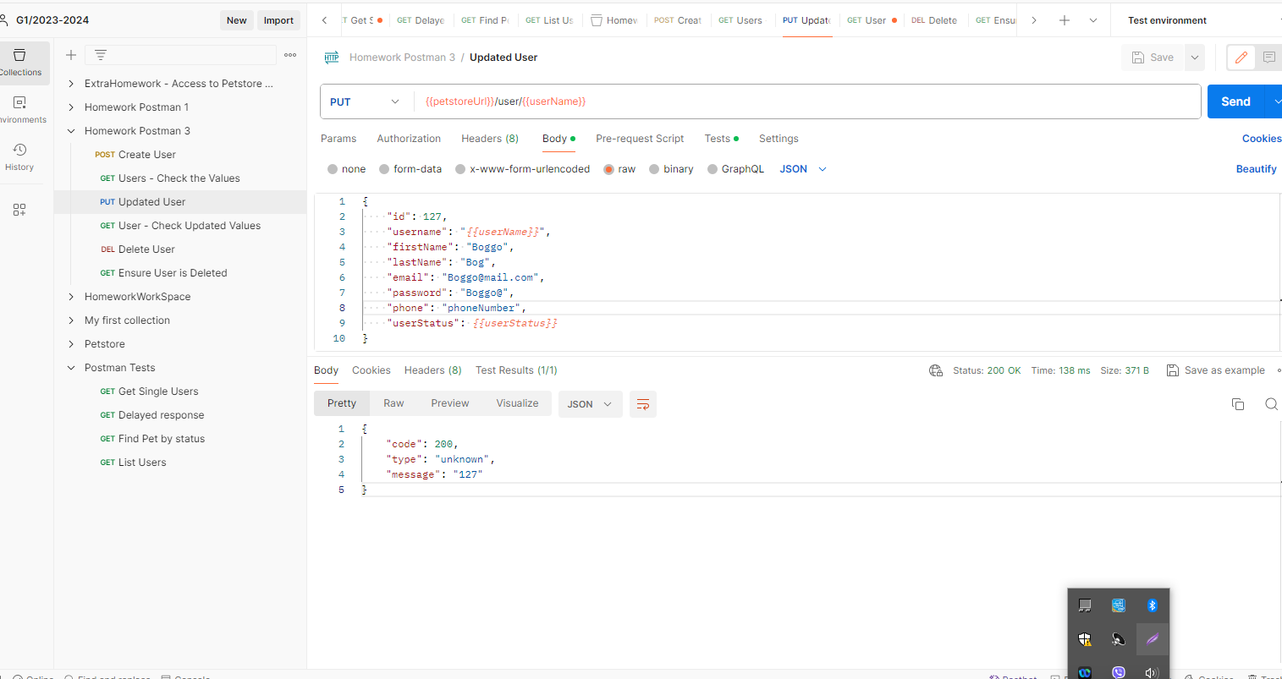

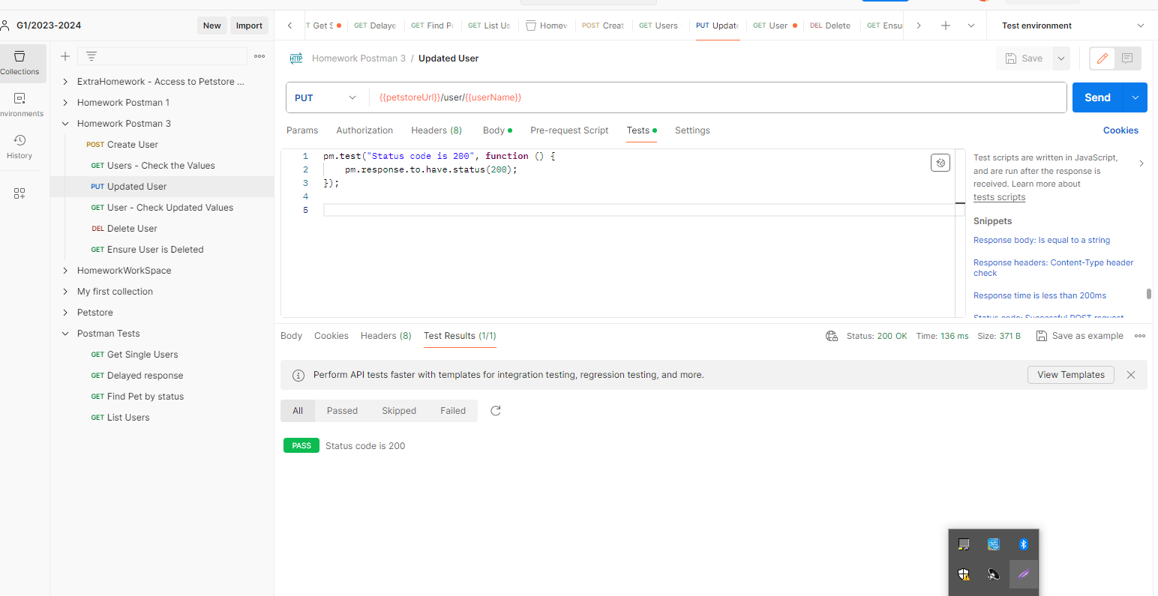

* GET/user/{username} - Check Updated Values

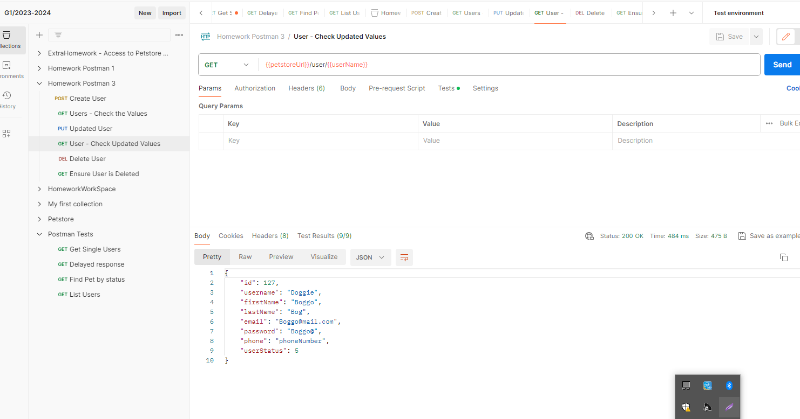

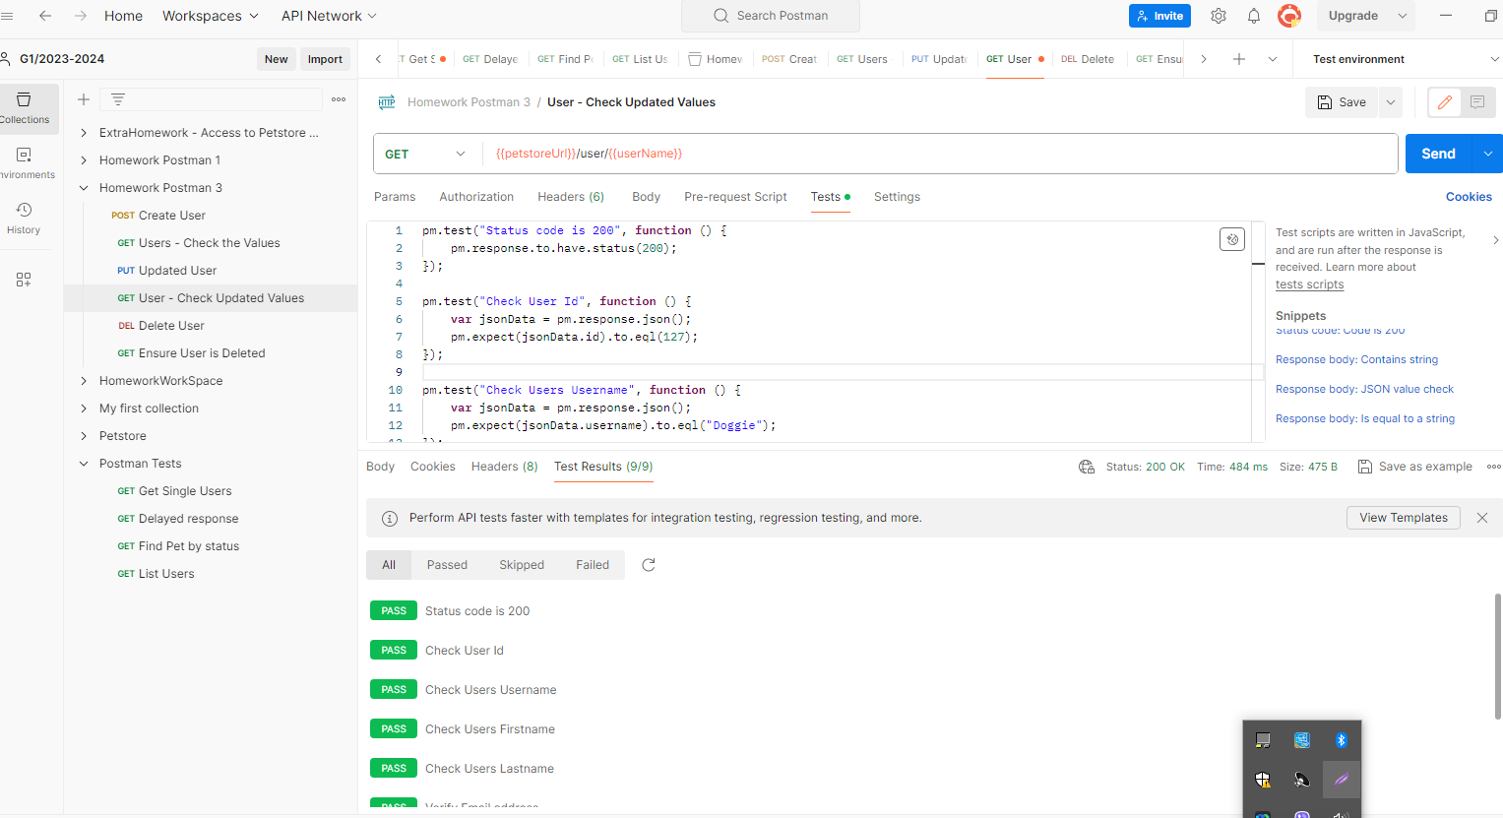

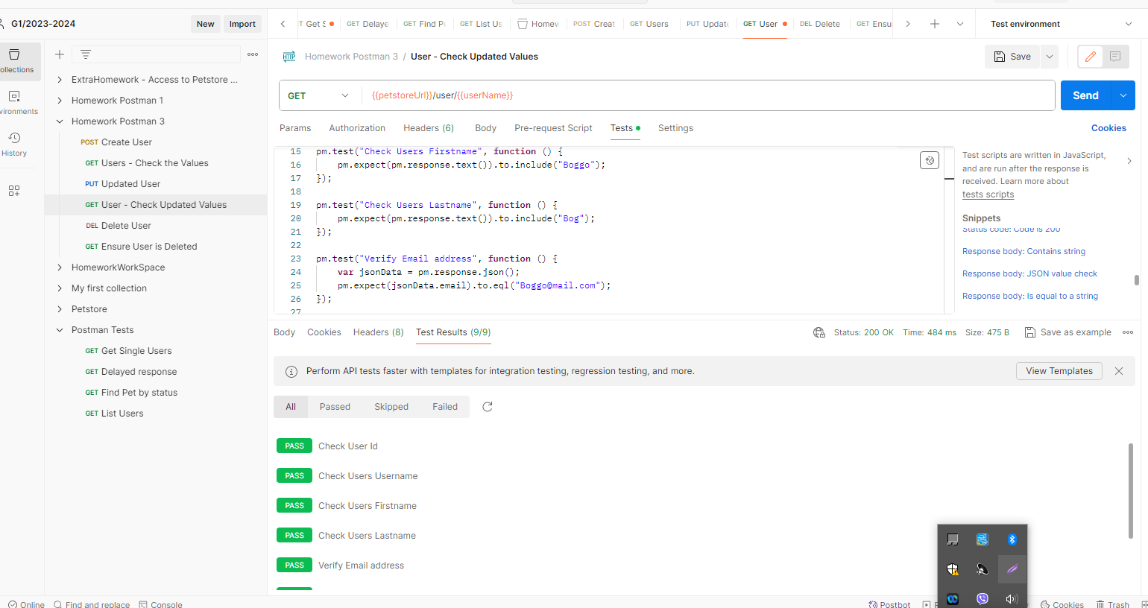

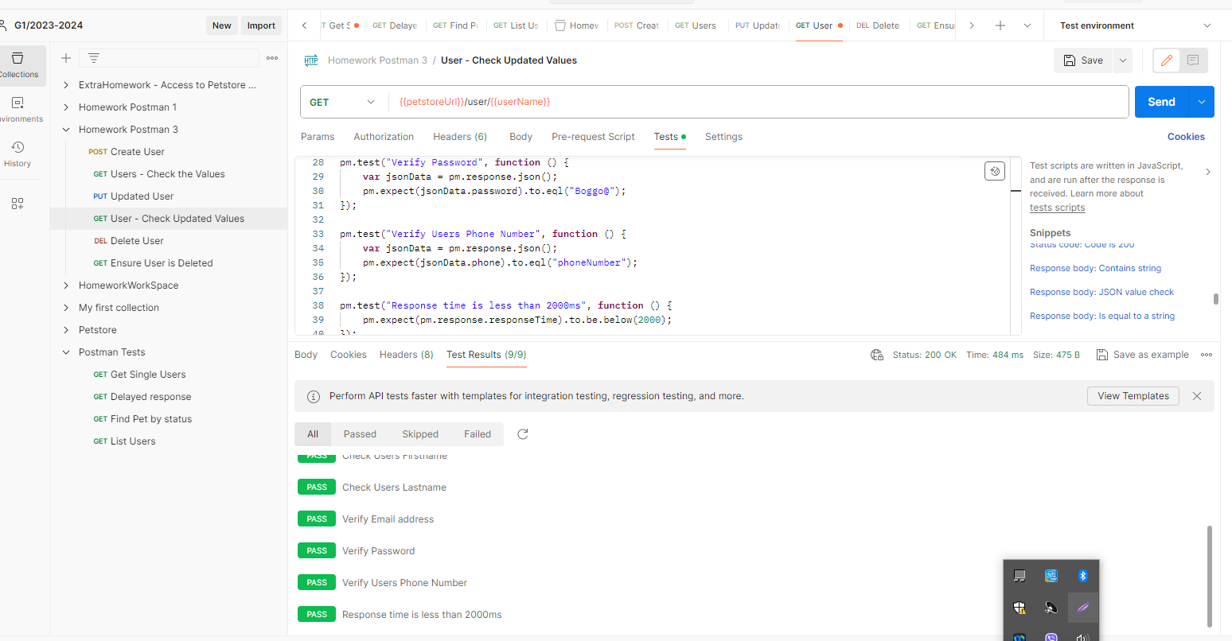

* Delete/user/{username}

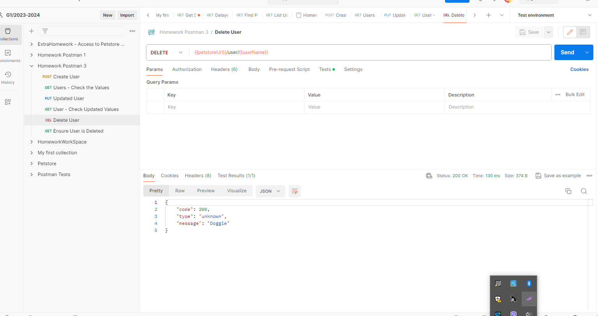

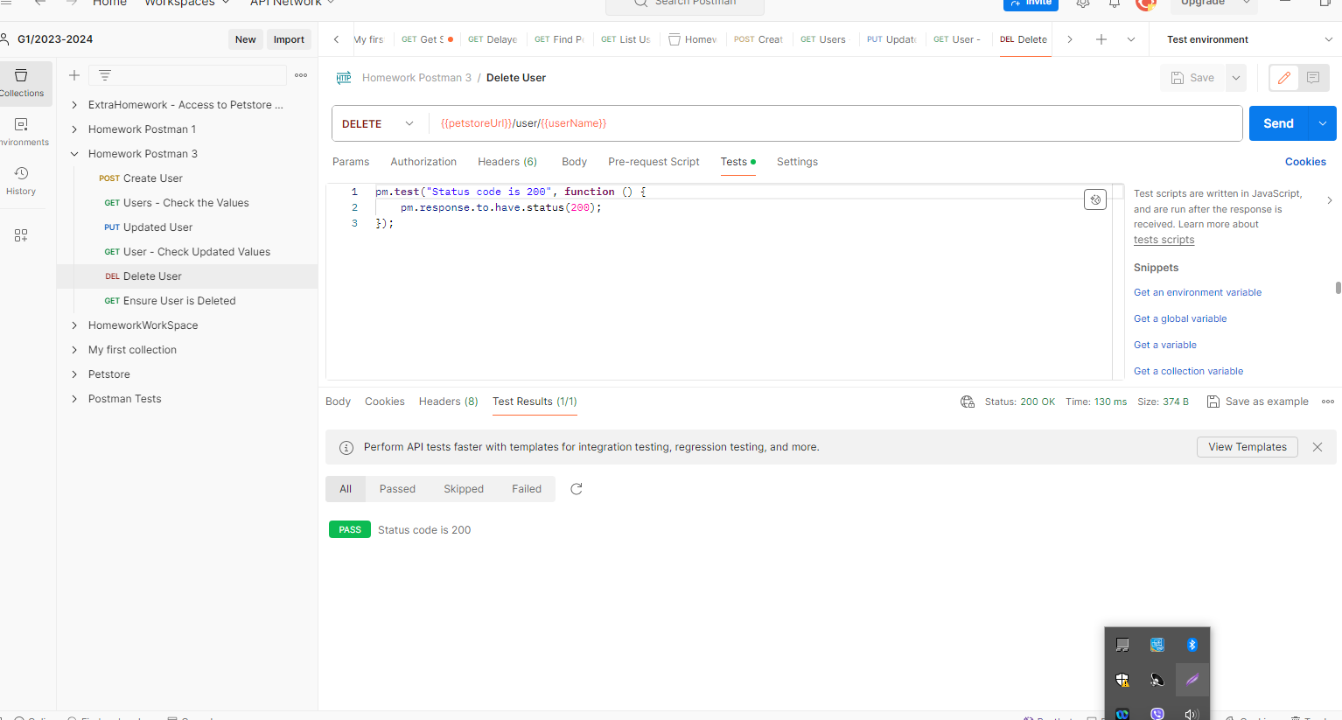

* GET/user/{username}

